**Assignment Name**: **Lab7:** (**Loops for & nested)**

**Due date:** **10/26/2022, by 11:00 am.**

**Grade for assignment: 20** points

**Purpose:** Obtain experience in using different types of loops, for and nested. Assignment accomplishes course learning objective “using basic control structures”. Assignment also provides preparation for COSC236 course, and enhances skills needed in Information Technology (IT) and Computer Science industries.

**Skills:** Purpose of assignment is to help you practice the following skills.

-Ability to use for loops and nested for loops

-Ability to effectively use loops in computer programs

**Knowledge:** Become familiar with when to use different control structures.

**\*\*\*\*\*\*\*\*\*\*\*\*\*\*\*\*\*\*\*\*\*\*\*\*\*\*\*\*\*\*\*\*\*\*\*\*\*\*\*\*\*\*\*\*\*\*\*\*\*\*\*\*\*\*\*\*\*\*\*\*\*\*\*\*\*\*\*\*\*\*\*\*\*\*\*\***

**Place your Name(s) below:**

**Pairs work:** Please work in pairs. **One student in team should submit work**. Put **your first and last name on the assignment** and **your partner’s first and last name on the** assignment

**Note(s):**

1. All programs should be completed within the Visual Studio Code environment. There are guides in blackboard to start you off with Visual Studio Code.

**Partner 1: Name Blessing Abumere**

**role (did the typing or read and review) _____________________________**

**Partner 2: Name ______________________________________________**

**role (did the typing or read and review)______________________________**

**Please note if one partner did not work on all problems.**

**Submission instructions:** All submissions will be done using blackboard. **Answers are to be submitted in a Microsoft word document.**

**Task**:

**Examples:** Refer to your notes from class, the Loops (Part1) PowerPoint, Loops (Part2) PowerPoint, in class exercises and any available videos (all located in Blackboard).

**Part1 (10 Points):**

1. Type in the following program. Add a comment at the top to include your name(s) and the date.

/*

    Blessing Abumere

    COSC 175

    10/19/2022

*/

#include <iostream>

using namespace std;

int main()

{

    int num;

    cout << "Counting " << endl;

    for (num = 0; num <= 5; num++)

    {

        cout << num << endl;

    }

    cout << "final value of num is " << num << endl;

    return 0;

}

-Compile and Run.

1. Explain the final value of num; (what is the value of num and how did it get that value).
   1. The final value of num is 6.
   2. The loop keeps iterating while num is less than or equal to 5 . When num has the value of 5 it still satisfies the loops condition of num <= 5 but when num becomes 6 the condition is false and the loop breaks leaving the nums final value equal to 6 .
2. Modify the program to count from **1 to 10** (rather than **0** to **5**).Compile and run.
3. **SUBMIT your corrected code, and sample of output (Below):**

/*

    Blessing Abumere

    COSC 175

    10/19/2022

*/

#include <iostream>

using namespace std;

int main()

{

    int num;

    cout << "Counting " << endl;

    for (num = 1; num <= 10; num++)

    {

        cout << num << endl;

    }

    cout << "final value of num is " << num << endl;

    return 0;

}

**Part2 (10 Points):**

1. Type in the following program. Add a comment at the top to include your name(s) and the date.
2. /*
3. Blessing Abumere
4. COSC 175
5. 10/19/2022
6. */
7. #include <iostream>
8. using namespace std;
9. int main(){
10. int num1;
11. int num2;
12. for (num1 = 0; num1 <= 1; num1++){
13. for (num2 = 1; num2 < 2; num2++){
14. cout << num1 << " " << num2 << endl;
15. }
16. }
18. return 0;
19. }

 -Compile and Run.

1. This is an example of nested for loops.
2. When is num1(num1++) in the outer loop incremented?
   1. The outer loop(num1) is only incremented after its nested loop(num2) has completely finished its loop
3. **SUBMIT code, and output (Below):**

/*

    Blessing Abumere

    COSC 175

    10/19/2022

*/

#include <iostream>

using namespace std;

int main(){

    int num1;

    int num2;

    for (num1 = 0; num1 <= 1; num1++){

        for (num2 = 1; num2 < 2; num2++){

            cout << num1 << " " << num2 << endl;

        }

    }

    return 0;

}

**\*\*\*\*\*\*\*\*\*\*\*\*\*\*\*\*\*\*\*\*\*\*\*\*\*\*\*\*\*\*\*\*\*\*\*\*\*\*\*\*\*\*\*\*\*\*\*\*\*\*\*\*\*\*\*\*\*\*\*\*\*\*\*\*\*\*\*\*\*\*\*\*\*\*\*\*\***

**Criteria for Success**:

**a**) Be sure to submit your code and output above for each question; **Submission of Code and output is required**. (Note: use screen shots or copy and paste).

For example if the assignment was to write a program that displays “Hello World”

Your **code** would be as follows:

//Lab1 answer COSC175002

#include <iostream>

using namespace std;

int main()

{

cout << "Hello, world" << endl;

system("pause");

} // end of main

Your **output** would be as follows:

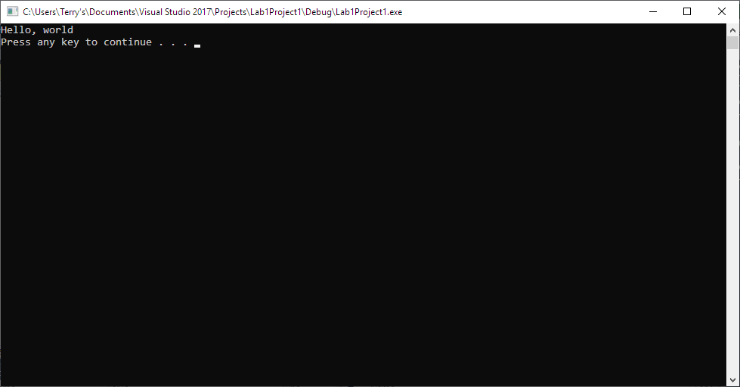

Note: To avoid additional point deductions; remember to submit both code and output.

>>>

**b)** Be sure to show completion of Security Injections by providing Screen shots of (or copy and paste) your Security Injection completion **Certificate** above**. Do not email me your certificate.**

**c) Late policy:** Late submissions will receive a zero grade. Get help during the week so that you can submit on time.